# CHAPTER 6: IMPLEMENTATION AND TESTING

## 6.1 Development environment.

My tools of development were Visual Studio Code, Figma, Xampp Control Panel, Mozilla Firefox browser and Microsoft Edge browser.

I used Figma, an online design tool, to come up with user interfaces for the project before coding begun. This helped ensure the user interface and user experience would be as good as possible.

HTML, CSS and Javascript are the languages I used to code the user interfaces, that is, the frontend side.

MySQL and PHP are the languages I used as the server-side / backend technology. I also used Google Maps Javascript API to show the locations of mechanics on maps.

## 6.2 System components.

### 6.2.1 Landing page

This is a page which depicts a brief overview of some of the functionalities offered by mechLocator. The navigation bar contains a several links that help the user navigate to various parts of the website. Navigation bar is also present in every page. The links include:

Home – A page which contains all functionalities in one place.

Mechanic near me – This page maps out locations of mechanics and a user can view the ones nearest to their position.

Our mechanics – This is a page which contains all registered mechanics on the platform.

Contact us – This has a contact form through which a user can contact us.

Log in – One can log in to a registered account.

Sign up – This page is used to register a user.

It then has brief details and advantages on some of the features offered. Below this is a testimonials section. User have listed how mechLocator has helped them to achieve something.

It ends with a footer which has quick links, vision and mission of mechLocator, and links to social media handles.

### 6.2.2 Motorist homepage

This page contains 6 buttons and the standard navigation bar. This page was made to ensure one can access all functionalities in one location easily. The buttons added are;

1. My repair history
2. Our mechanics
3. Add new car
4. Add repair record
5. Mechanic near me
6. Apply to be a mechanic

### 6.2.3 Add a new car pop up

This is a pop up window in which a user can add the number plate of his/her car.

### 6.2.4 Mechanic near me page

This page maps out locations of mechanics and a user can view the ones nearest to their position.

### 6.2.5 My repair history page

This page shows the repair activities which have being recorded for each car registered under a user’s account. The records are sorted per date and per number plate.

For each separate day, it gives the total of the repair cost. It also has a button for adding a new repair record.

### 6.2.6 Add a Repair record page

This page gives a form for adding a repair activity and the cost of the activity. A mechanic can record an activity for any vehicle registered in the system and save the record.

A user is only able to record a repair activity for his/her own car. He cannot record an activity for a car which is not registered under his account.

### 6.2.7 Our Mechanics page

This is a page which contains all registered mechanics on the platform and the average rating they have gotten from users.

### 6.2.8 Apply to be a mechanic page

This page is used to register a user as a mechanic. It gets the users location coordinates and asks for a location name from the user. It then stores this in the database.

### 6.2.9 Notifications page

This page is used to show a user that a new record activity has being added for one of his/her vehicles.

Through this page, the user can view the mechanic who added the activity and also rate the services provided out of 5. He can also leave a review message.

### My profile page

This page outlines the user’s profile. It shows the name, phone number, email and cars registered in his account. For mechanics, it has an additional button for updating their location details.

A user can edit his/her personal details and save the changes. There is also a button for deleting an account.

### Admin panel page

This page is meant for the administrator. Through this page, the admin can view the total number of users, mechanics and cars.

It also provides a list of car owners, mechanics and cars with their respective owners.

## 6.3 Test plan

To ensure proper functionality of the system, testing was thoroughly done. I choose to test each module of the system one at a time so as to ascertain nothing was overlooked.

Therefore, since the modules were each working properly, then the overall system was also well-functioning.

### 6.3.1 Test cases and results

Table Test cases and results

|  |  |  |  |  |
| --- | --- | --- | --- | --- |
| **TEST** | **Test ID** | **Inputs** | **Expected Output** | **Actual output** |
| **REGISTRATION** | 1 | All input fields are entered | True | True |
| 2 | Some input fields are missing data | False | False |
| **LOG IN** | 3 | Valid user log in details | True | True |
| 4 | Invalid log in details | False | False |
| **MECHANIC REGISTRATION** | 5 | User’s location coordinates | True | False |
| **SEARCH FOR MECHANIC** | 6 | User location coordinates | True | True |
| **ADD A NEW CAR** | 7 | Has already logged in. | True | True |
| 8 | Not logged in. | False | False |
| **ADD A REPAIR RECORD** | 9 | Logged in as a mechanic | True | True |
| 10 | Logged in as a user | True | True |
| **VIEW REPAIR RECORDS** | 11 | Logged in. | True | True |
| 12 | Not logged in. | False | False |

Based on the test cases and test results above, the system showed high level of integrity and functional support.

Seeing that the actual output matched the expected output is an indicator that the system objective was achieved.

# CHAPTER 7: RESULTS AND CONCLUSION

## 7.1 Achievements and lessons learnt

Creating a fully functional website with backend support has being a great achievement for me. I have also successfully incorporated Google Maps API, therefore mapping out user coordinates has been made a whole lot easier.

The website is responsive. It works well in all devices, for example, desktops, mobile phones, tablets etc. Browser support is also great. Any browser which supports Javascript can successfully run the website and be of help to a user.

The user interface is appealing to the eye and quite engaging. It is user-friendly, thus can be easily used by the target audience, that is, drivers and mechanics.

I have learnt a lot about system development while working on this project. Below are some the key lessons learnt:

1. **Time management**

Through implementing the project, I have seen the importance of planning your project well before beginning. They say, *“Not planning is planning to fail”*. Which basically implies that if you do not have a plan, you will most likely fail to achieve your goal.

One needs to realize the scope of the project, the time and resources available and then come up with a schedule. This will ensure you stay on track and you can measure your achievements based on the set goals.

Failure to plan leads one to doing things haphazardly. This in turn leads to development of a system which fails to meet some of the set objectives.

1. **Effective research methods**

While conducting research on existing similar systems, I learnt how to; conduct extensive research on a specific topic, document the information gathered and how to properly do citation.

This will aid me in future projects as it will help me gain more information on topics of interest. Through this I have also learnt about plagiarism and the importance of avoiding it.

1. **User interface designing**

Through the project I learnt several tips about User Interface/User Experience (UI/UX) design and some of the best practices.

For example, I have learnt how to best design forms so as to ensure they are understandable to all target users and how to map out a user journey.

1. **Project documentation process**

Documentation is a very important aspect in every project development. Proper system documentation ensures that the system was developed as needed and it meets the set objectives.

I have learnt how to review other system’s documentation and how to document a project I’m working on.

1. **Soft skills / people skills**

Through development of the project, I have interacted with a large variety of people, for example, mechanics, people who own vehicles, senior developers etc. I have learnt key communication skills such as listening keenly to what others have to say and how to express my opinion in a clear and respectful manner.

## 7.2 Conclusion

This project was implemented with mechanics and car owners in mind. The main goal was to connect car owners to competent mechanics. The main goal has been achieved through the use of the website.

Since the solution is a website, it works across all devices, be it laptops, tablets or mobile phones, so long as the device is connected to the internet.

## 7.3 Recommendations

Due to the constraints of time, some functionalities could not be achieved. Below are the recommendations I would make to further improve the solution:

1. Sending a reminder to car owners to perform a regular repair service, such as engine oil service. This would help ensure the cars remain in good conditions all the time.
2. Building a chat room where users and mechanics can discuss issues such as best practices to prevent battery damage. The chatroom could have a Question and Answer feature, where users can post questions and mechanics can answer.

# REFERENCES

Auto Repair by Top-Rated Mobile Mechanics | YourMechanic. (2019). Retrieved from Yourmechanic.com website: https://www.yourmechanic.com/

mCarFix | Take Charge. (n.d.). Retrieved October 25, 2021, from mCarFix website: https://www.mcarfix.com/

# APPENDIX

## User manual

Upon loading the website, which when locally hosted by Xampp Server, can be accessed via the link <http://localhost/mechLocator/index.php> .

This will land the user in the landing page. There is a call to action button for registration which takes the user to the Sign up page. One can also view mechanics near his/her location even though not logged in. However, the other functionalities such as Viewing repair records cannot be accessed if one is not logged in. A valid email address should be used to register.

While in the maps page, the website can give you directions to the mechanic’s location. There is also a choice of contacting him/her via email, WhatsApp or phone call.

After logging in, a user can add his/her own car into the system by simply inputting the car number plate.

When a mechanic does a repair, he/she states the repair activities done and their respective cost. The owner of the car repaired in turn gets a notification that the repair has been done. While viewing the repairs done, a user can rate the services provided.

## Data collections tools

I used a questionnaire to collect information on some of the requirements from users.

[Project questionnaire form (google.com)](https://docs.google.com/forms/d/e/1FAIpQLSd6RwXM-Iag1ZqETh8lP7rg757VKPXrurnO0-Rf-CU0trzdCg/viewform)

to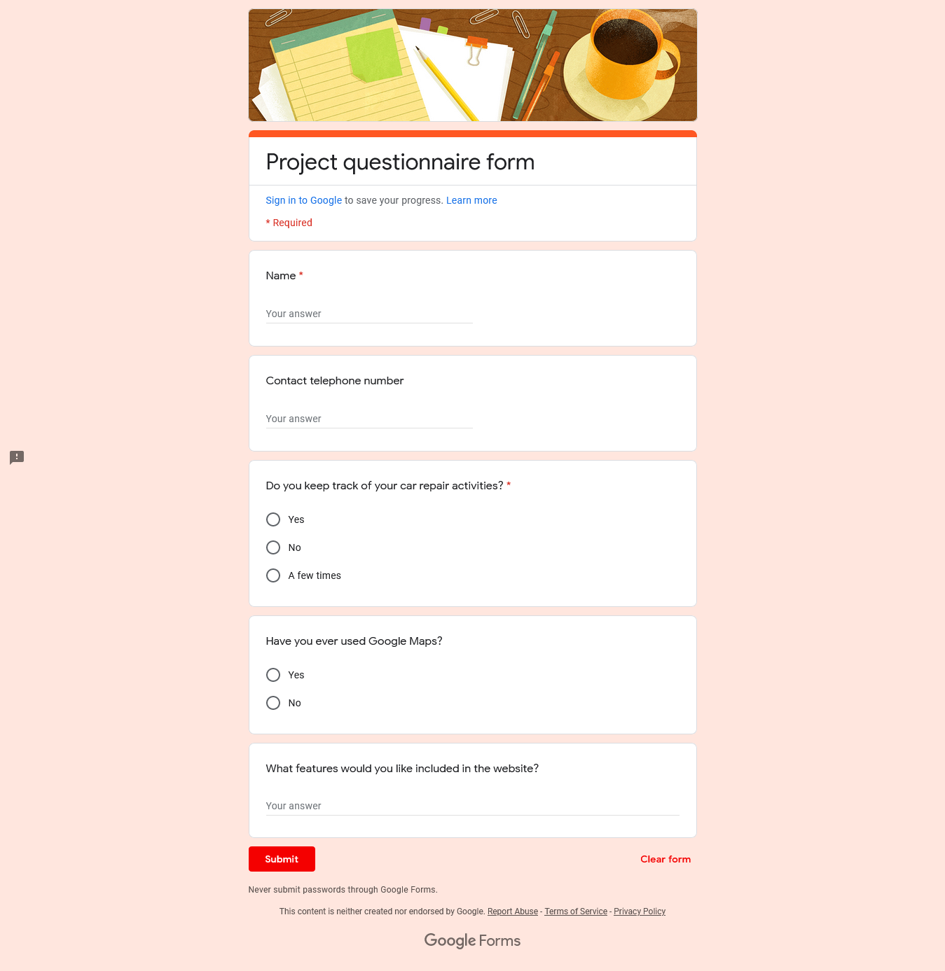

Figure Questionnaire form

## Project schedule

I used a Gantt chart to show the progress of development of the system.

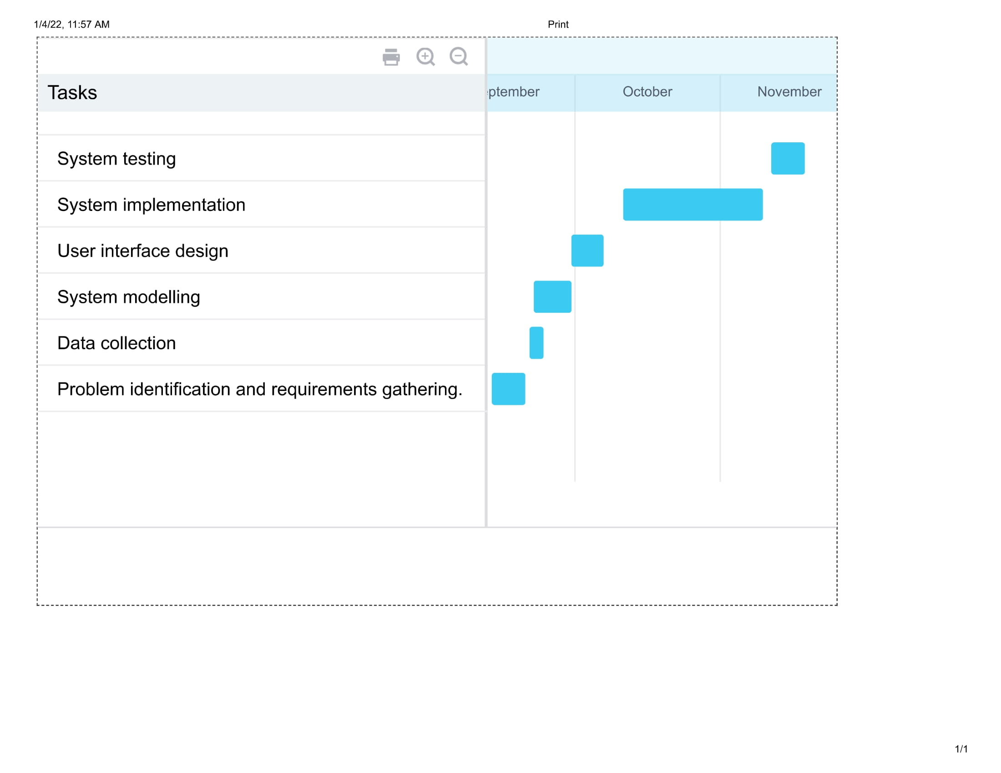

Figure Project Gantt chart

## Project budget

Table project budget

|  |  |
| --- | --- |
| **ACTIVITY** | **COST (Kshs)** |
| Data collection | 1000 |
| Data analysis | 500 |
| Internet fee | 2000 |
| Travel for consultation | 500 |
| Miscellaneous | 1000 |
| **Total cost** | **5000** |